**SOLANO COMMUNITY COLLEGE**

**MT 164, PROGRAMMABLE LOGIC CONTROLLERS**

Spring, 2018

PLC PROGRAMMING LAB 11 - FESTO AUTOMATION TRAINER: PT 2

**Catharine Crayne**

**05/13/2018**

**OBJECTIVE**:

1. To write a ladder logic program the will incorporate the use of subroutines and timers.

**Group Members:**

**-**

**MATERIALS**: Micrologix 1100 Trainer Unit, Festo Automation Trainer

**SAFETY AND EQUIPMENT NOTES:**

1. Turn off trainer when attaching wires

**PROCEDURE**:

**Part 1: Research**

1. Investigate one section of the Festo Automation Trainer. Trainer Station: _Sorting_______
2. Write down the steps and sequence of its operation. Use the animation found on the course’s Google Drive.
3. Apply 24V power to the Input Sensor wiring block and identify and locate each sensor.
4. List out the Input Sensors and describe what they do.

I:0/0 - Part_AV – Detects if a puck has been placed on the conveyer belt

I:0/1 - B2 – Inductive Sensor – Senses metal puck

I:0/2 - B3 – Capacitive Sensor – Senses the red & silver puck, but not the black one

I:0/3 - B4 – Retro-reflective sensor/break beam – Sensor detects if object has gone down slide

I:0/4 – K1 - Push button to stop/start conveyer belt motor

1. List out the Outputs and describe what they do.

O:0/0 – M1 – 12V power for Conveyer belt

O:0/1 - 1B1 – Compact/pneumatic cylinder – Arm that pushes the red puck down the slide

O:0/2 - 2B2 – Compact/pneumatic cylinder – Arm that pushes the silver puck down the slide

O:0/3 – Solenoid

O:0/4 – IP_N_FO – Sends a signal to the corresponding Festo terminal letting it know that it can receive input (a puck)

**Part 2: Testing outputs**

1. Write a ladder logic program that will energize an output when a push button is pressed.
2. Download your program to your Micrologix PLC trainer and wire up the push button and the output.
3. Connect Ground to your output block on the FAT. Use the output from your PLC to power various output components on the FAT to see how they will work. You may need to provide air to your FAT.

**Part 3: Writing the control program**

1. Now begin to write the control program for the FAT. It should use a push button to start it, and a safety stop to stop it. Use these buttons on your trainer. Think about how to use subroutines to make your program easier to read and troubleshoot. Program it in stages. Keep in mind if the start conditions or reset conditions that may be needed for it to work. If your FAT uses more than 10 Inputs, devise a way to split the program between two PLCs.
2. Verify that it works. Print out your program(s).

**Part 4: Communicating to another station**

1. Modify your program and PLC wiring to utilize the SEND/RECEIVE transmitter. If you are using the Distributing Station, you will not use your start button, but instead wait for an input from the Testing Station indicating it is ready for a puck transfer. Similarly, if you have the Testing station, you will need to replace the Start button with an input from the Sorting Station and output a signal to the Distributing Station at the completion of each puck test. And if you have the Sorting station, you will use your Start button to initiate the whole sequence… outputting a signal to the Testing station.

**RESULTS - DATA**

Part 2: Snapshot of our program. 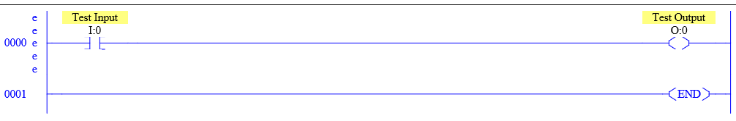

Part 3 & 4: Snapshot of our program.

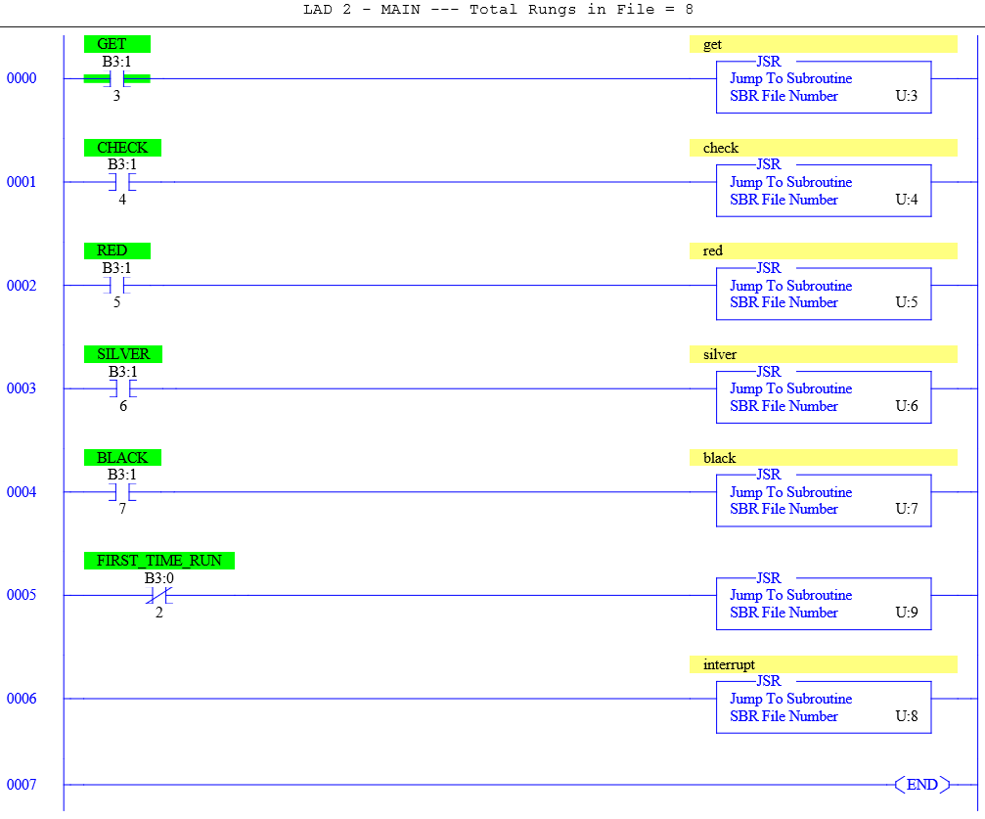

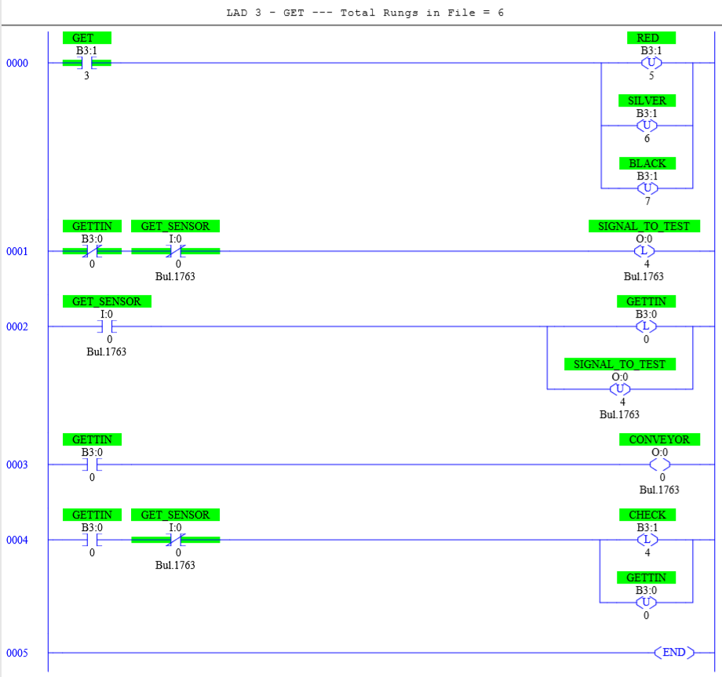

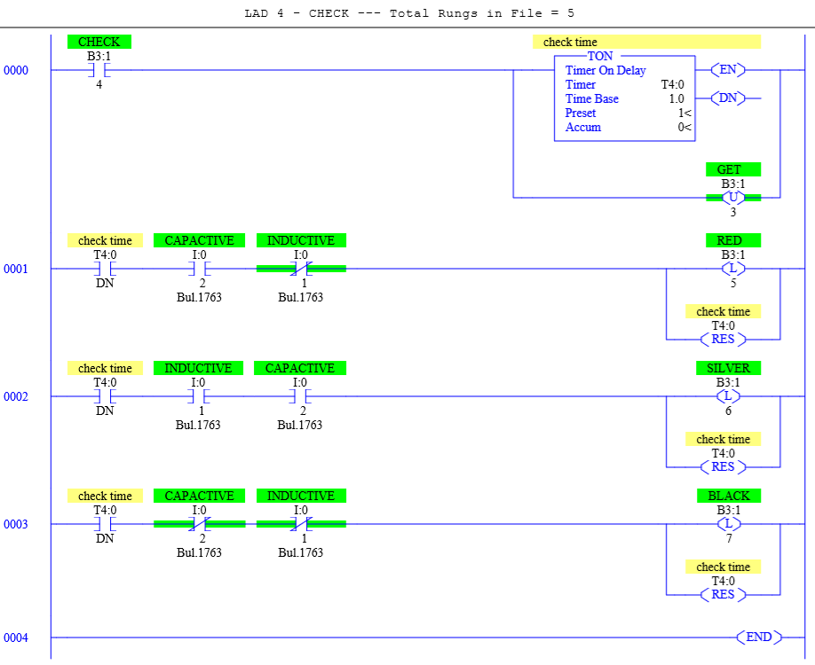

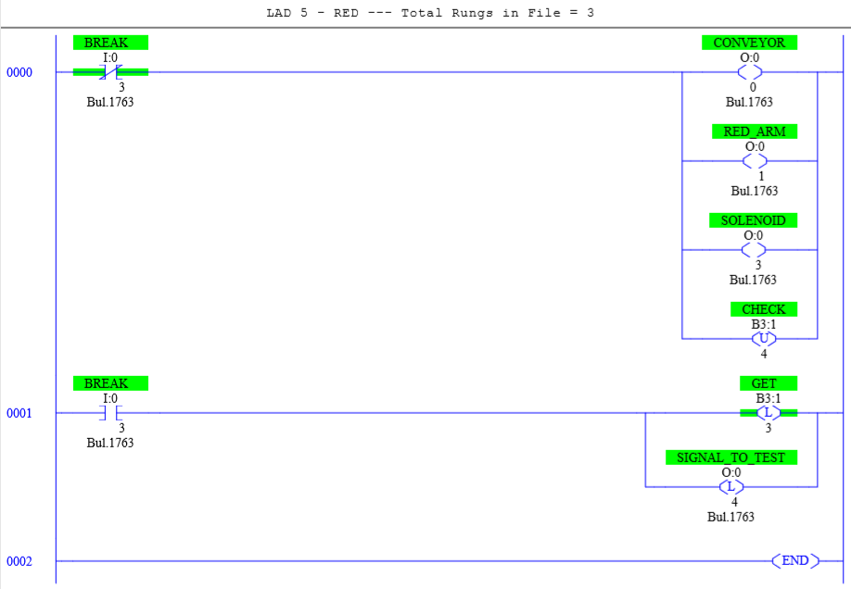

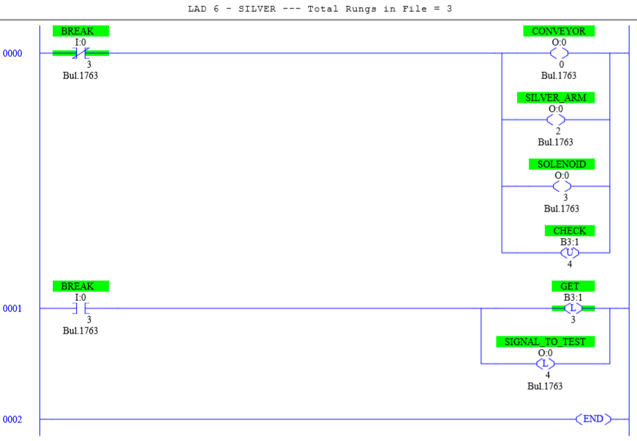

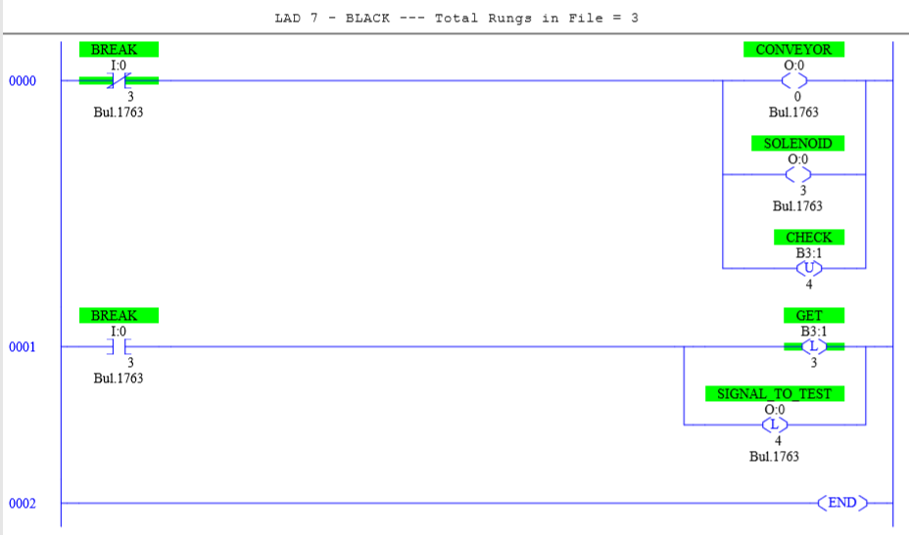

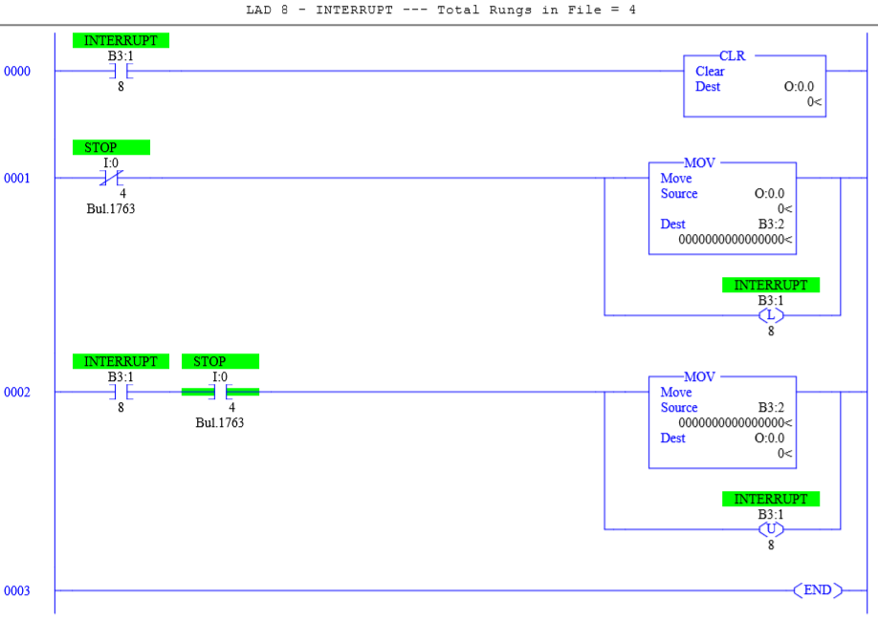

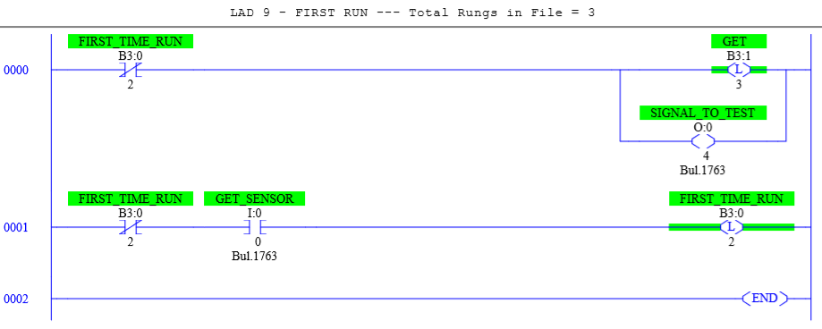

**OBSERVATIONS**

Part 1: Picture of our setup

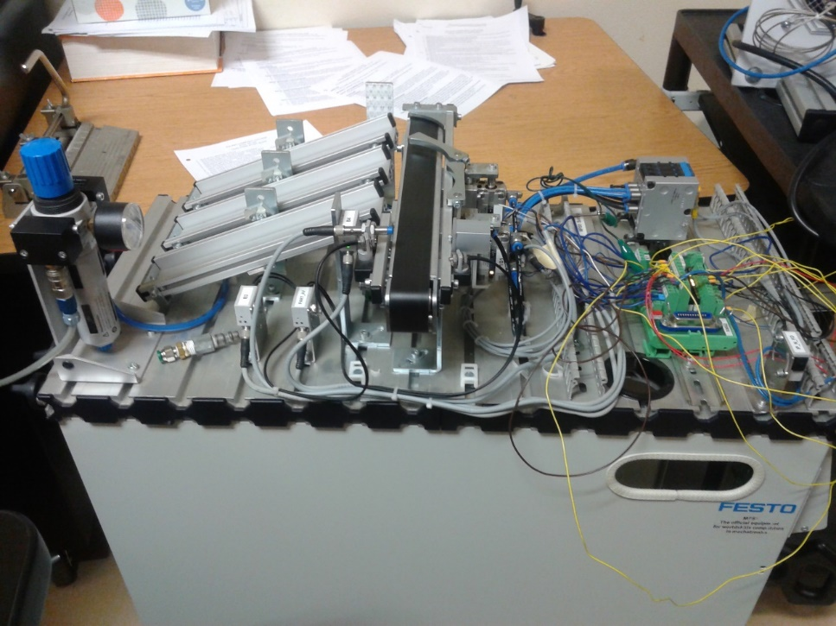

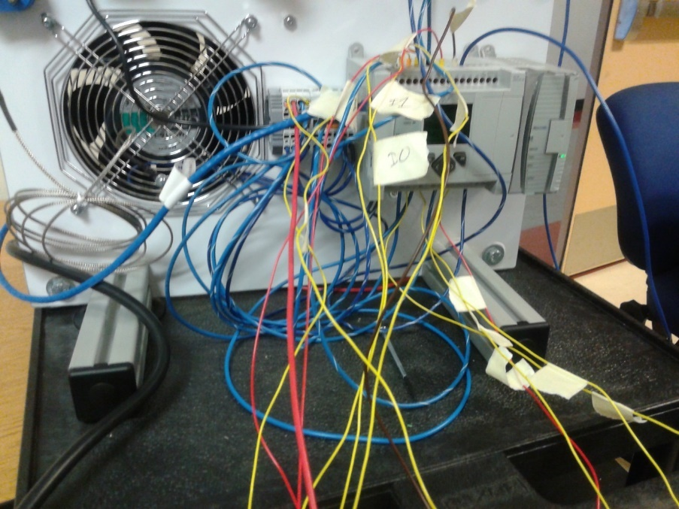

**ANALYSIS QUESTIONS:**

1. If one PLC controlled all three of these stations, how many inputs and outputs would be required?

*Inputs = 7 + 10 + 5 = 22*

*Outputs = 5 + 4 + 5 = 14*

1. Which of the three stations required the most use of bitwise logic? Explain why.

*The Testing station used the most bitwise logic because the function of the program is to compare input values from sensors to determine puck size and type (metal or non-metal). While the Sorting station also measures puck type (metal, non-metal, or other), it does not measure the size of the puck. The Testing station’s physical setup also requires clearance of certain areas prior to being able to function (for safety reasons) and so multiple conditions must be met before the physical movement of the mechanical appendages can be executed. The Distribution station only has one bitwise logic function that is required for operation.*

1. Which of the three stations depended the most on the use of timers? Why?

*The Testing station depends the most on the use of timers because the physical action of the output (lowering or raising the lift) does not execute as quickly as the program can change the value. You risk breaking the machine and/or having the physical execution not match the program if you do not include timing delays in the programming for this station.*

1. How can you add one simple rung to your program make all outputs zero using the Fill File command?

*Add a rung with a FLL command, use a location with a value of 0 as the Source, in the destination write #O:0, and in length write 5 (or total number of outputs).*